# C++ Worksheet :: loops

Using the loops **for**, **while** and **do while** (a do while may not make sense for some of the tasks) complete the following tasks:

1. Output numbers from 1 to 10

2. Output numbers 0 to 10

3. Output numbers 10 to 1

4. Output square numbers up to 10

5. User enters a number, output numbers 1 to that number

6. Output dice rolls and the running total. Stop when the total is larger than 27. E.g:

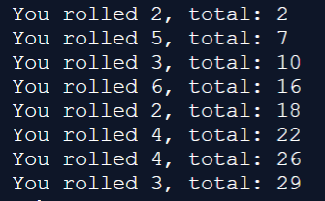

7. Sum numbers up to user entered value. E.g. I enter 5, you display 1+2+3+4+5 = 15

8. Output the times table (user selected):

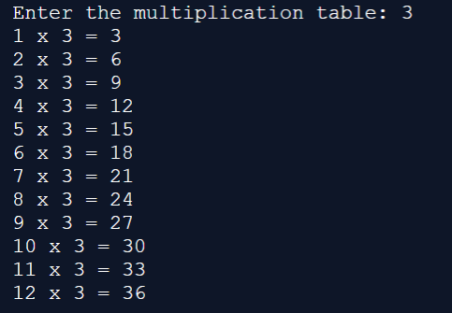

9. Output the following:

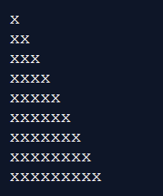

10. Output the following:

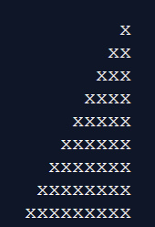

11. Output the following:

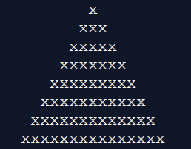

12. Output the following:

